1. What is JavaScript?

* JS is a programming language. We use it to give instructions to the computer.
* JavaScript is a dynamic typed language.

1. Setting up VS Code </>

* 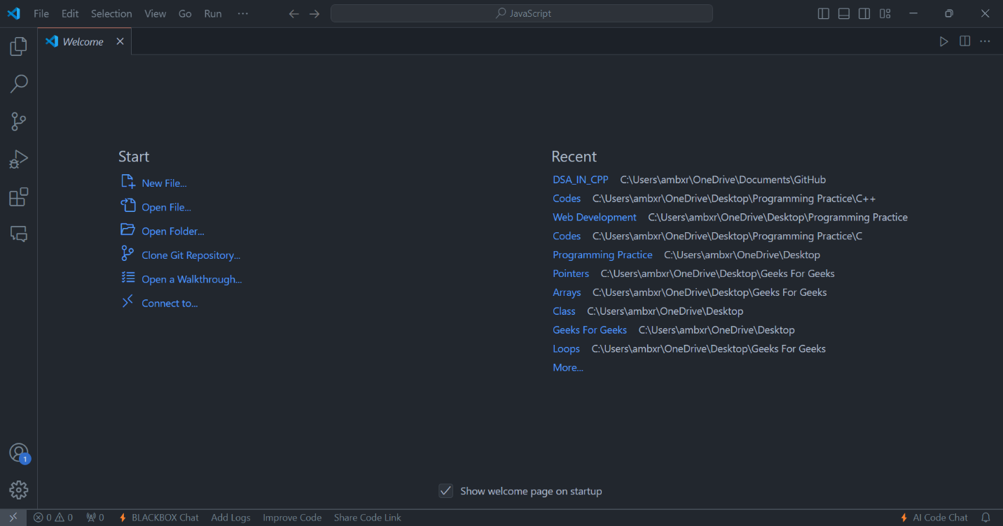It is a free & popular code editor by Microsoft.
* Objects – It is a collection of different types of values.

1. Our 1st JS Code

* A screen shot of a computer

  Description automatically generatedConsole.log is used to log (print) a message to the console.

1. Variables in JS

* Variables are containers for data.

1. Variable Rules
   * 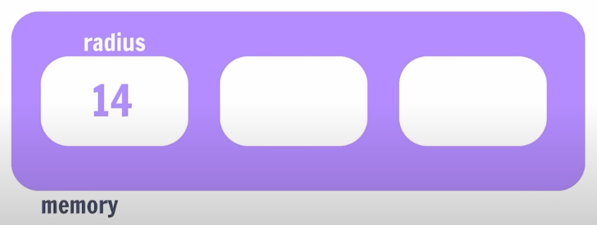Variable names are case sensitive; “a” & “A” is different.
   * Only letters, digits, underscore (_) and $ are allowed. NOT even space.
   * Only a letter, underscore (_) or $ should be 1st character.
   * Reserved words cannot be variables name.
2. let, const & var
   * var: Variable can be re-declared & updated. A global scope variable.
   * let: Variable cannot be re-declared but can be updated. A block scope variable.
   * const: Variable cannot be re-declared or updated. A block scope variable.
3. Data Types in JS
   * Number, String, Boolean, Undefined, Null, BigInt, Symbol.
   * Data Types are of two types:
     1. Primitive - 7
     2. Non-Primitive – Objects (Arrays, Functions)